# CNT 4007C - Theory and Fundamentals of Computer Networks Homework Assignment 4

**Problem 1 – 3 Points**

Using the CSMA/CD back-off algorithm, compute the conditional probabilities of two nodes A and B having collision numbers as 1 and 3 respectively. Illustrate the probability of A’s and B’s chance for winning the collision and the chance for a no collision.

N = 1; [0, 21-1] = [0,1] possibilities for A

N = 3; [0, 23-1] = [0,7] possibilities for B

Possibilities for A Possibilities for B

0 0

0 1

0 2

0 3

0 4

0 5

0 6

0 7

1 0

1 1

1 2

1 3

1 4

1 5

1 6

1 7

2 collisions, 1 B win, 13 A wins; P(A) = 13/16 P(B) = 1/13 P(NO COLLISION) = 14/16

**Problem 2 – 4 Points**

Refer to the figure provided below. Assume Host A is sending Host B a frame. Describe the steps clearly, as to how this process would happen, if ARP table of Host A and router are empty.

Host A is going to package the message and send it through the wire to the router. The router will determine the receiving host and send out a signal to to ask who owns the required MAC address (except host A because the router received the message from them). Host B will respond saying “I’m that guy.” The router will then send the message to Host B.

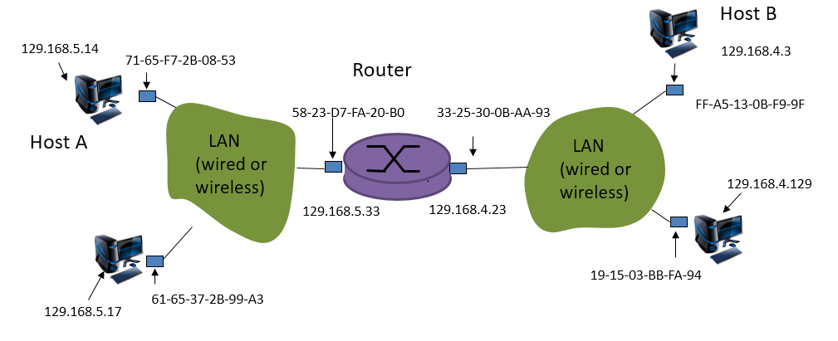

**Problem 3 – 5 Points**

Page. 366 -- P6 [Chapter 4]

Range Interface # of addresses

00000000 – 00111111 0 26=64

01000000 – 01011111 1 25=32

01100000 – 01111111 2 25=32

10000000 – 10111111 2 26=64

11000000 – 11111111 3 26=64

### Problem 4 – 4 Points

### Consider sending a 2,000-byte datagram into a link with a MTU of 980 bytes. Suppose the original datagram has the identification number 227. How many fragments are generated? For each fragment, what is its size, what is the value of its identification, fragment offset, and fragment flag?

### Header size = 20

### 2000-20 = 1980 net datagram size

### MTU = 980 – 20 = 960 fragment size

### 1980/960 = 2.**** = 3 fragments

### Fragment ID is the same as datagram ID = 227

### Fragment 1 & 2 size = 980 each and fragment 3 size = 2000 – 960*2 = 80

### Fragment 1 offset is 0 and flag is 1

### Fragment 2 offset is 960/8 = 120 and flag is 1

### Fragment 3 offset is 960*2/8 = 240 and flag is 0 to indicate last fragment

### Problem 5 – 4 Points

### Refer to the posted “IP Analysis” Wireshark lab instructions and answer the following questions:

### 1. Select the first ICMP Echo Request message sent by your computer, and expand the Internet Protocol part of the packet in the packet details window. What is the IP address of your computer?

### 2. Within the IP packet header, what is the value in the upper layer protocol field?

### 3. How many bytes are in the IP header? How many bytes are in the payload of the IP datagram? Explain how you determined the number of payload bytes.

### 4. Has this IP datagram been fragmented? Explain how you determined whether the datagram has been fragmented.

Submission Instructions:

1. Submit a single pdf document for your solution to all problems. Submitting multiple files may result in deduction of points.
2. Your submission must list your name, major, date of submission and course prefix [CNT 4007C] on the header area.